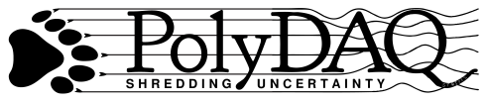
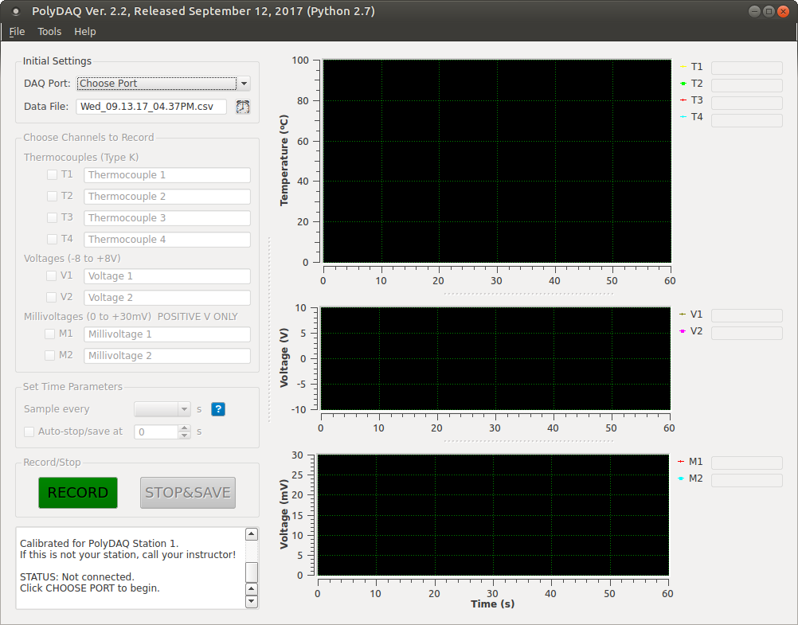  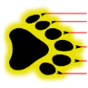  START  PolyDAQ  SYSTEM | Turn monitor on.  Quick Start Guide  Press power button  on PolyDAQ (Boots PolyDAQ and the Raspberry Pi).
LOG IN | Login: student Password: gosset
CONNECT  SENSORS | Power  (ON only)  Data Port  Thermocouples  (Type K)  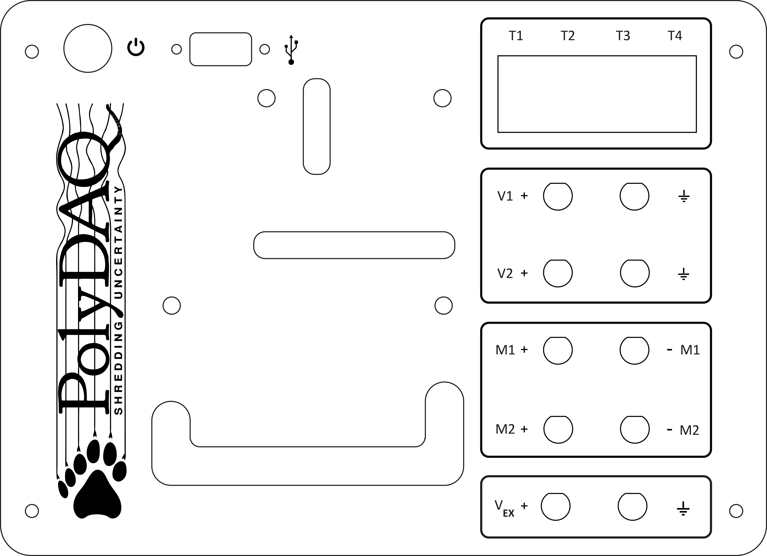  Voltage  (-8 to +8 V)  Raspberry Pi  (computer)  Millivoltage  (0 to +30 mV)  PolyDAQ Board  Excitation Voltage  +3.3 V (out)  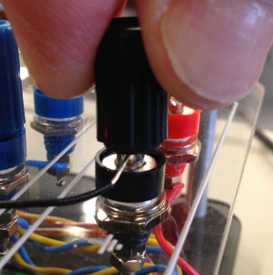  Note: Binding posts take banana plugs or bare wires. To connect bare wires, feed through side hole and tighten binding nut as shown at right.
RUN  THE CODE | From the Desktop: open PolyDAQ:  Choose DAQ port → /dev/ttyUSB0  - Connection ERROR? Select Choose Port  again and repeat.  Rename file (optional). Click the clock button  to reset the file name to date and time format.  Select channels to record.  Rename the selected channels (these names  will appear in the data file).  Set the sample rate. NOTE: the minimum sample  rate is about 0.005s per sample for each channel.  Click the information button for details.  OPTIONAL: Select and set an auto-stop time.  RECORD or STOP the data acquisition.
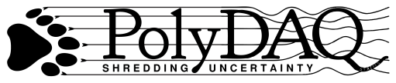

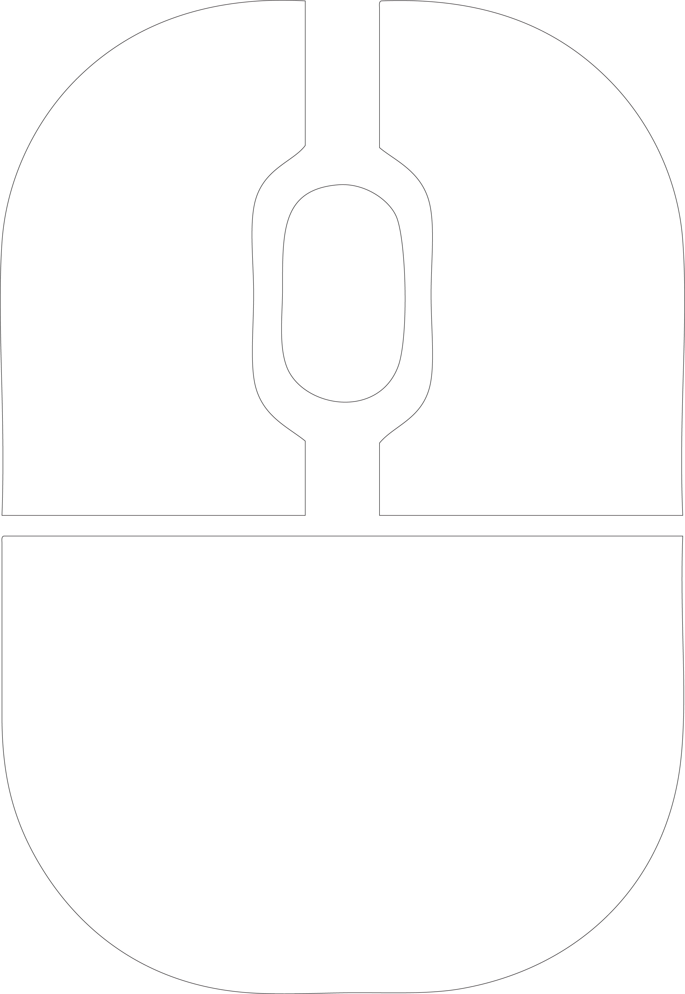
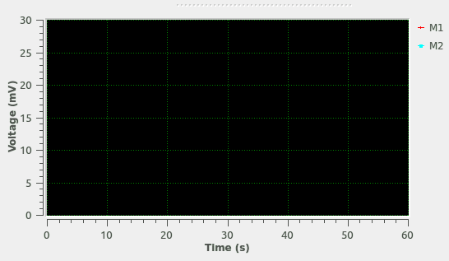
PLOT NAVIGATION AND
LEGEND ITEMS
AXES
Quick Start Guide
Pan
Zoom
Menu
Menu
Resize/Remove Plot
Roll: Zoom
Click: Zoom Window
Pan
Back
MOUSE CONTROLS

[Click the Help menu for more details]
RETRIEVE  DATA FILES |  | Data files are stored on the Desktop in the PolyDAQ_Data_Files folder. The files are the type comma-separated values (.csv).  To retrieve: copy files a thumb drive via the USB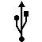port, or e-mail the file.
OPEN FILE |  | Excel will open .csv files automatically. If the file is not visible, choose All Files in the File Open menu.  For other programs like LibreCalc, the software may ask you the format of the file. Select Comma-Delimited as the type.
SAVE FILE AS… |  | When saving your file within Excel, be sure to change the file type to Excel Workbook (.xlsx).  In LibreOffice, change the file type to ODF Spreadsheet (.ods).
SYSTEM  SHUTDOWN |  | Do NOT perform a “hard” shutdown on the system! It can corrupt the Pi’s operating system.  To properly shut down: select Shutdown from the Power button 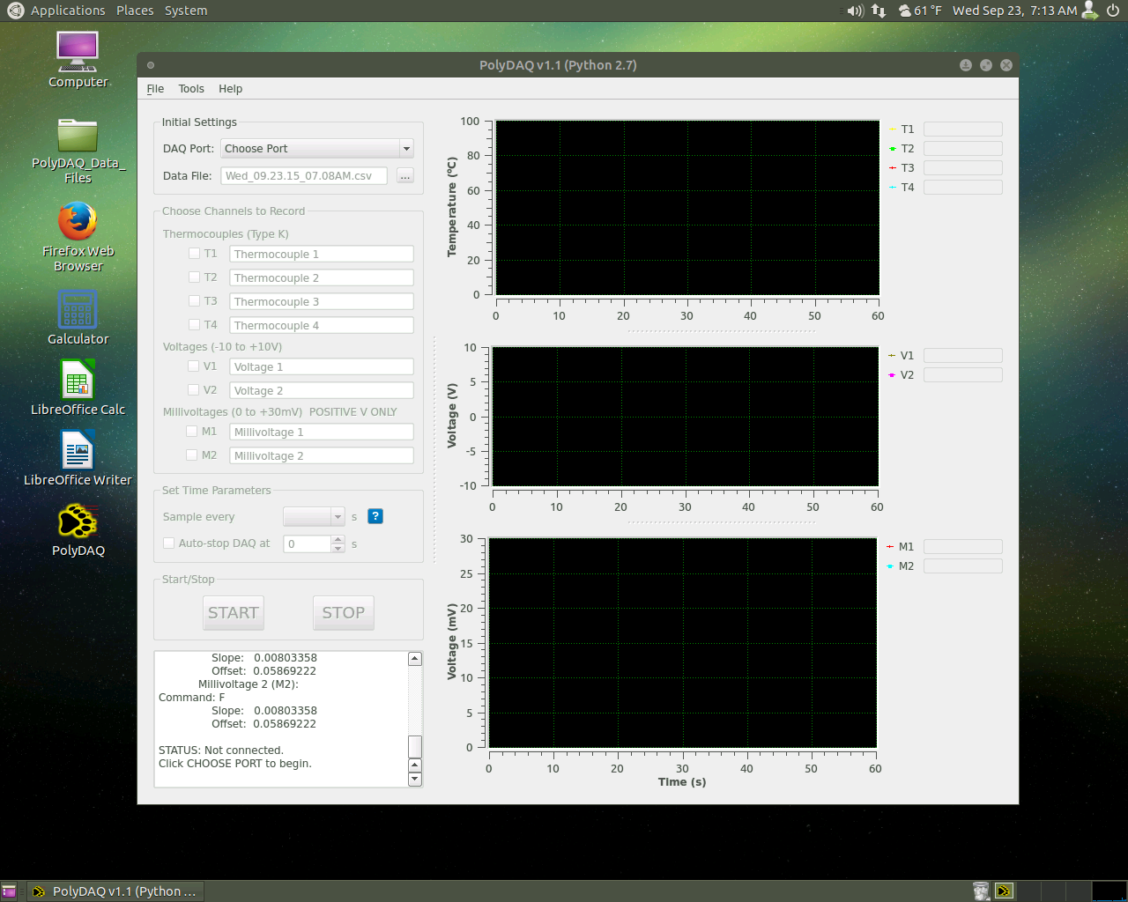 the top right corner of the desktop screen. Turn monitor off.  Or, to log out: select Switch User at the top right corner of the desktop screen. Select Log Out.

PolyDAQTM is a computerized data acquisition (DAQ) system designed and fabricated in the Cal Poly Mechanical Engineering department. The hardware was designed by Dr. John Ridgely, and is similar to hardware you may be designing in your Mechatronics courses. The software was written by Dr. Glen Thorncroft using the Python programming language, and is installed on a Raspberry Pi running the Ubuntu MATE operating system.

